Assignment 1
Name :Nabiha Sabir
Roll no : su92-bssem-s24-019
SOFTWARE CONSTRUCTION AND DEVELOPMENT
Week 4 Laboratory Assignment
From a Monolithic Program to Cohesive Python Modules
Part A — Code Archaeology
The original program contains several different responsibilities inside the main() function.
Responsibility Identification
def main():
name = input("Enter student name: ")
marks = []

for i in range(3):
mark = float(input(f"Enter marks for subject {i + 1}: "))

while mark < 0 or mark > 100:
print("Invalid marks. Enter 0-100.")
mark = float(input(f"Enter marks for subject {i + 1}: "))

marks.append(mark)

total = sum(marks)
average = total / len(marks)

if average >= 80:
grade = "A"
elif average >= 70:
grade = "B"
elif average >= 60:
grade = "C"
elif average >= 50:
grade = "D"
else:
grade = "F"

print("\nStudent Result")
print("----------------")
print("Name:", name)
print("Total:", total)
print("Average:", average)
print("Grade:", grade)

main()
Summary
Responsibility | Code in original program
INPUT | input() statements for student name and marks
VALIDATION | while mark < 0 or mark > 100
CALCULATION | sum(marks) and total / len(marks)
GRADING/BUSINESS RULE | if average >= 80, elif...
DISPLAY | print() statements
The main problem is that main() is doing too many different jobs. This makes the program harder to maintain and change.

Part B — Responsibility Map
Responsibility | What does it do? | Where should it live?
Input | Gets the student's name and marks from the user | main.py
Validation | Checks whether a mark is between 0 and 100 | validation.py
Calculation | Calculates total and average | calculations.py
Grading Rule | Determines A, B, C, D or F based on average | calculations.py
Display | Displays the student's result | display.py
Explanation
The input and overall coordination can remain in main.py because it is the entry point of the application.
Validation should be separated because its responsibility is specifically to determine whether marks are valid.
Calculations and grading are related to the student result, so they belong in calculations.py.
Display should only display information. It should not calculate the grade because that would mix presentation with business logic.

Part C — Design the Modules
The proposed structure is:
student_marks/
│
├── main.py
├── validation.py
├── calculations.py
└── display.py
1. Why does each module exist?
main.py
main.py is responsible for coordinating the application. It gets input, calls validation and calculation functions, and sends the final information to the display module.
validation.py
This module contains validation-related logic. Its purpose is to check whether marks are valid.
calculations.py
This module contains calculations and grading rules. It calculates the total, average, and grade.
display.py
This module handles how the result is shown to the user. It does not perform calculations.

2. Which functions belong in calculations.py?
The following functions belong there:
calculate_total(marks)
calculate_average(marks)
calculate_grade(average)
These functions are related because they all deal with producing the student's result.

3. Should display.py calculate the grade?
No.
display.py should only be responsible for displaying information.
For example, it should receive:
name
total
average
grade
and print them.
If display.py calculated the grade, it would have two responsibilities: displaying information and implementing business rules. This would reduce cohesion and make future changes more difficult.

4. What should main.py coordinate?
main.py should coordinate the flow of the application:
Get input
↓
Validate marks
↓
Calculate total
↓
Calculate average
↓
Calculate grade
↓
Display result
It should not contain all the implementation details itself.

5. Which implementation details should other modules not need to know?
Other modules should not need to know:
- How the user enters marks.
- How many times input() is called.
- How results are printed.
- How the grade is displayed.
- Where the grade thresholds are displayed.
- How the user is asked to enter another mark.
For example, calculations.py should not contain input() or print() statements.

Part D — Implementation
validation.py
def validate_mark(mark):
return 0 <= mark <= 100
This function checks whether a mark is valid.
A mark from 0 to 100 returns True.
A mark such as -5 or 105 returns False.

calculations.py
def calculate_total(marks):
return sum(marks)

def calculate_average(marks):
return calculate_total(marks) / len(marks)

def calculate_grade(average):
if average >= 80:
return "A"
elif average >= 70:
return "B"
elif average >= 60:
return "C"
elif average >= 50:
return "D"
else:
return "F"
This module contains the calculation and grading logic.

display.py
def display_result(name, total, average, grade):
print("\nStudent Result")
print("----------------")
print("Name:", name)
print("Total:", total)
print("Average:", average)
print("Grade:", grade)
This module only displays the result.

main.py
from validation import validate_mark
from calculations import calculate_total, calculate_average , calculate_grade
from display import display_result

def main():
name = input("Enter student name: ")
marks = []

for i in range(3):
mark = float(input(f"Enter marks for subject {i + 1}: "))

while not validate_mark(mark):
print("Invalid marks. Enter 0-100.")
mark = float(input(f"Enter marks for subject {i + 1}: "))

marks.append(mark)

total = calculate_total(marks)
average = calculate_average(marks)
grade = calculate_grade(average)

display_result(name, total, average, grade)

if __name__ == "__main__":
main()
How the modules work together
main.py
/ | \
↓ ↓ ↓
validation calculations display
|
↓
total / average
|
↓
grade
The original required behaviour is maintained, but the responsibilities are now separated.

Part E — Dependency Mapping
The dependency diagram is:
main.py
/ | \
↓ ↓ ↓
validation calculations display
6. Which modules does main.py depend on?
main.py depends on:
- validation.py
- calculations.py
- display.py
It imports functions from all three modules.

7. Does display.py need to know how the grade is calculated?
No.
display.py only needs to receive the already calculated grade.
For example:
display_result("Ali", 225, 75, "B")
It does not need to know why 75 produces a "B".

8. Does calculations.py need to know how results are printed?
No.
calculations.py only calculates values.
For example:
average = calculate_average(marks)
grade = calculate_grade(average)
It doesn't matter whether the result is printed on the terminal, displayed in a GUI, or written to a file.

9. What would happen if display.py were replaced by a GUI?
The calculation logic would not need to change.
We could replace:
display.py
with something such as:
gui.py
The GUI could call the same calculation functions.
For example:
main.py
↓
calculations.py
↓
GUI
This is an advantage of modularity because presentation can change without changing the business logic.

10. Which dependencies are necessary and which are unnecessary?
Necessary dependencies
main.py → validation.py
because main.py needs to validate marks.
main.py → calculations.py
because main.py needs the total, average and grade.
main.py → display.py
because main.py needs to display the result.
Unnecessary dependencies
display.py → calculations.py would be unnecessary.
Display does not need to calculate anything.
Similarly:
calculations.py → display.py
would be unnecessary because calculations should not know how results are presented.

Part F — Change Request Test
11. Change 1: Grading changes to A ≥ 85, B ≥ 75, C ≥ 65, D ≥ 55.
Only:
calculations.py
needs to change.
The function would become:
def calculate_grade(average):
if average >= 85:
return "A"
elif average >= 75:
return "B"
elif average >= 65:
return "C"
elif average >= 55:
return "D"
else:
return "F"
The other modules remain unchanged.

12. Change 2: The result format changes.
Only:
display.py
needs to change.
For example, if we want:
Ali - Total: 225 - Average: 75 - Grade: B
we only modify the display function.

13. Change 3: The validation message changes.
The validation-related code in main.py needs to change because the current validation message is printed there:
print("Invalid marks. Enter 0-100.")
If we wanted to isolate the message completely from main.py, we could move the user-input/validation interaction into a separate input module. However, for this assignment's requested structure, changing the message in main.py is sufficient.

14. Change 4: Results will later be displayed through a GUI.
The display layer should be replaceable.
Instead of:
display.py
we could have:
gui.py
The calculation logic in calculations.py would remain unchanged.
This demonstrates change isolation.

Part G — Verification
Test 1: Normal marks
Marks:
75, 82, 68
Calculation
Total = 75 + 82 + 68
= 225

Average = 225 / 3
= 75
Grade:
75 >= 70
Therefore:
Grade = B
Expected output:
Student Result
----------------
Name: [student name]
Total: 225.0
Average: 75.0
Grade: B

Test 2: Boundary marks
The grading boundaries are:
Average | Expected Grade
50 | D
60 | C
70 | B
80 | A
This confirms that the >= conditions work correctly.

Test 3: Invalid marks
Input:
-5
The program should display:
Invalid marks. Enter 0-100.
and ask for the mark again.
Input:
105
The same validation should occur.
Therefore, marks below 0 or above 100 are rejected.

Test 4: Second student
For example:
Student: Sara
Marks: 90, 85, 95
Calculation:
Total = 270
Average = 90
Grade = A
Expected result:
Name: Sara
Total: 270.0
Average: 90.0
Grade: A
This confirms that the program works for different students and different marks.

Reflection
15. What is the difference between separating code into functions and separating code into modules?
Functions separate a program into smaller units of behaviour within the code.
For example:
calculate_average()
is one function responsible for calculating an average.
Modules separate related functions into different files.
For example:
calculations.py
contains calculation-related functions.
Therefore, functions provide smaller units of responsibility, while modules organize related responsibilities at a larger level.

16. Which module has the strongest cohesion? Explain.
I think calculations.py has strong cohesion because all of its functions are related to producing the student's result.
It contains:
calculate_total()
calculate_average()
calculate_grade()
All three functions deal with calculations or business rules concerning student marks.
Similarly, display.py also has very high cohesion because its only responsibility is displaying the result.

17. Give one example of coupling in your program.
main.py is coupled to the other modules because it imports their functions:
from validation import validate_mark
from calculations import calculate_total, calculate_average, calculate_grade
from display import display_result
This coupling is necessary because main.py coordinates the application.
However, the coupling is relatively manageable because the modules do not depend heavily on each other's internal implementation.

18. How does modularity help when requirements change?
Modularity allows changes to be isolated.
For example, if the grading system changes from:
A >= 80
to:
A >= 85
we only need to modify calculate_grade() in calculations.py.
If the output format changes, we modify display.py.
Therefore, modularity reduces the amount of code that needs to be changed and lowers the possibility of accidentally breaking unrelated parts of the program.

19. Did you create a module that is too broad or too small? Explain.
I don't think any of the modules are unnecessarily broad or small for this application.
validation.py has one main responsibility: validation.
calculations.py contains related calculations and grading rules.
display.py handles presentation.
main.py coordinates the application.
For such a small program, creating many more modules would probably make the program unnecessarily complicated. The current four-module structure provides a reasonable balance between separation and simplicity.

Dependency Diagram
The final dependency structure can be represented as:
┌─────────────┐
│ main.py │
└──────┬──────┘
│
┌─────────────┼─────────────┐
↓ ↓ ↓
┌────────────┐ ┌──────────────┐ ┌────────────┐
│validation │ │ calculations │ │ display │
│ .py │ │ .py │ │ .py │
└────────────┘ └──────────────┘ └────────────┘
A key design principle is that:
display.py ──X──> calculations.py
calculations.py ──X──> display.py
Neither module needs to depend on the other.

Part C/D Overall Design
The final project should look like this:
student_marks/
│
├── main.py
│
├── validation.py
│
├── calculations.py
│
└── display.py
Responsibility overview
main.py
│
├── Get user input
├── Coordinate program
│
├──────→ validation.py
│ └── Validate marks
│
├──────→ calculations.py
│ ├── Calculate total
│ ├── Calculate average
│ └── Calculate grade
│
└──────→ display.py
└── Display result

Part 13 — Semester Project Connection
For my semester project, I would first identify the major responsibilities instead of immediately creating modules. For example, if the project is a Library Management System, possible responsibilities could include:
Library Management System
│
├── User Management
│
├── Book Management
│
├── Borrowing/Returning
│
├── Validation
│
├── Calculations/Fines
│
└── Display/User Interface
A possible structure could then be:
library_system/
│
├── main.py
├── users.py
├── books.py
├── borrowing.py
├── calculations.py
├── validation.py
└── display.py
The exact structure would depend on the actual requirements of the semester project. I would avoid creating a module just because it is possible; each module should have a clear and cohesive responsibility.
The main goal would be to keep modules loosely coupled so that a change in one part of the project does not require unnecessary changes in other parts.

Final Conclusion
The original student marks program works, but it is monolithic because input, validation, calculations, grading and display are all mixed together in one function.
After refactoring, the responsibilities are separated:
Input/Coordination → main.py
Validation → validation.py
Calculations/Grade → calculations.py
Display → display.py
This improves cohesion because each module has a focused responsibility and reduces unnecessary coupling between different parts of the application.
The biggest benefit is change isolation. For example, changing the grading rules only requires modifying calculations.py, while changing the output format only requires modifying display.py. This makes the program easier to understand, test, maintain and extend.

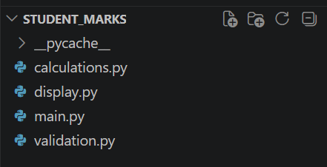
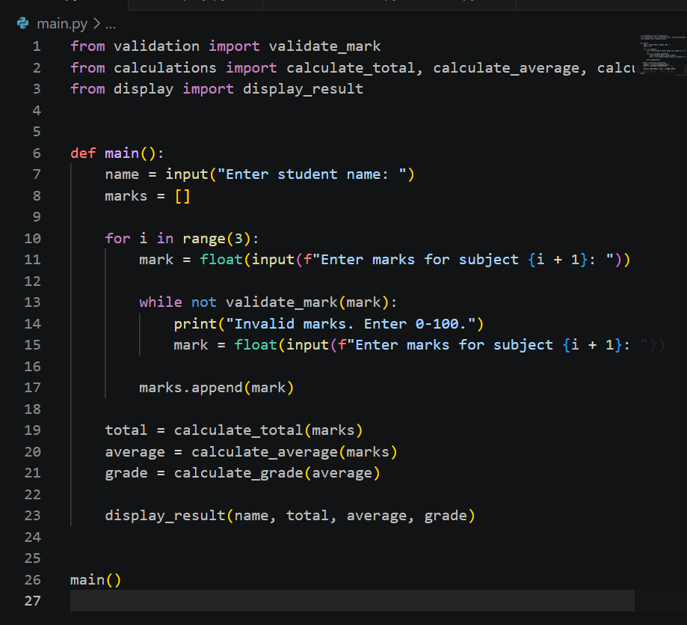
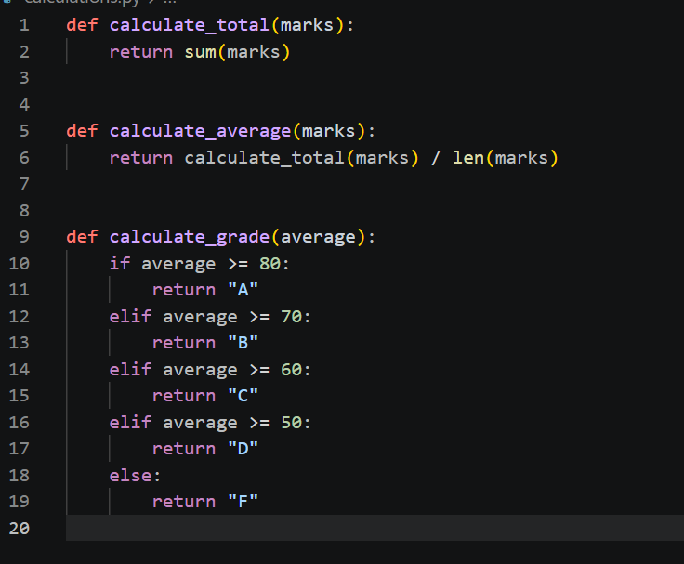
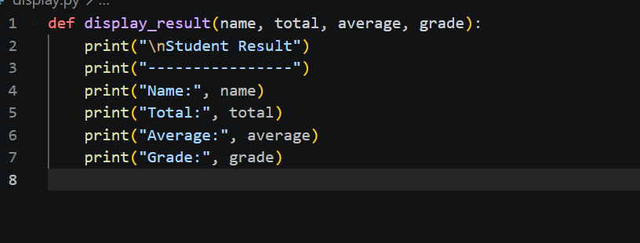
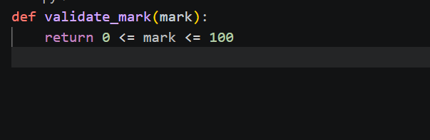
Output
